SAVITRIBAI PHULE PUNE UNIVERSITY

A Project Report On

Vintage Parts India – Discontinued Automobile Marketplace

Submitted Towards The
Partial Fulfillment Of The Requirements Of

BSc in Blockchain Technology 2025-2026
Submitted By
Nishit Bhalerao ( Roll No :-BSC24BCT18 )

Under The Guidance of
Assistant Prof. Sahil Shaikh

Accepted By
Department of Technology
SAVITRIBAI PHULE PUNE UNIVERSITY

ABSTRACT

Vintage Parts India is a comprehensive web-based marketplace system developed to address the growing challenges in sourcing rare and discontinued automobile components. In the current scenario, vintage vehicle owners and restoration enthusiasts face significant difficulty in locating genuine spare parts due to fragmented markets, unreliable sellers, lack of centralized platforms, and absence of transparency in pricing and authenticity.

The proposed system provides a centralized digital solution that connects buyers and sellers through a structured and user-friendly platform. Users can register, browse available parts, apply filters based on category, vehicle type, price range, and availability, and make informed purchasing decisions. Sellers can list their products with detailed descriptions, images, and pricing, thereby increasing visibility and accessibility.

The system is designed using modern web technologies including React.js for frontend development, Node.js and Express.js for backend services, and MongoDB for database management. It follows a scalable client-server architecture ensuring high performance, security, and maintainability.

Vintage Parts India enhances efficiency, reduces search time, improves reliability, and creates a trustworthy ecosystem for vintage automobile transactions. The platform aims to digitize the traditional offline marketplace and provide a seamless experience for users.

ACKNOWLEDGEMENT

It gives us great pleasure and satisfaction to present the final project report on
“VINTAGE PARTS INDIA – VINTAGE AUTOMOBILE MARKETPLACE SYSTEM”.

We sincerely express our gratitude to our project head Assistant Prof. Sahil Shaikh for their valuable guidance, continuous support, and motivation throughout the development of this project. Their suggestions and technical knowledge helped us successfully complete this work.

We would also like to thank the Head of Department Dr. Aditya Abhyankar, all teaching staff, and faculty members of Savitribai Phule Pune University for providing the necessary resources and academic environment.

Index
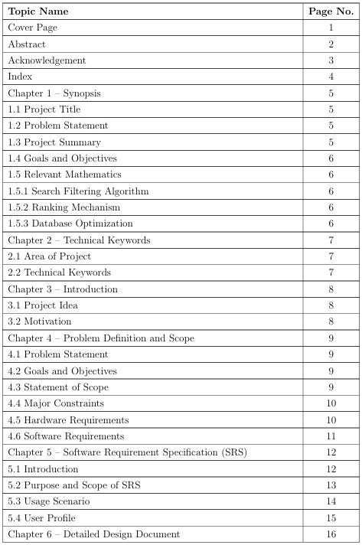
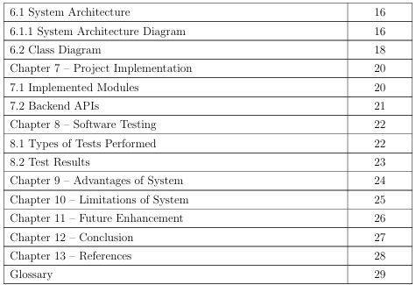

CHAPTER 1 – SYNOPSIS

  - Project Title
Vintage Parts India – Vintage Automobile Marketplace System

  - Problem Statement
The process of finding vintage automobile parts is currently inefficient, time-consuming, and unreliable. Most users depend on offline sources such as local markets, personal contacts, or unverified online listings. These methods lack transparency, standardization, and trust, leading to issues such as counterfeit products, inconsistent pricing, and limited availability.

Additionally, there is no centralized platform that aggregates sellers and buyers of vintage parts, making the search process scattered and inefficient. This results in increased effort, wasted time, and poor user experience.

Therefore, there is a need for a digital platform that can centralize the marketplace, ensure authenticity, and provide efficient search and transaction mechanisms.

  - Project Summary
Vintage Parts India is designed as a full-stack web application that enables users to buy and sell vintage automobile parts efficiently. The system provides functionalities such as user registration, product listing, search and filtering, and order management.
The platform is divided into three main modules:
- User Module – for buyers to search and purchase parts
- Seller Module – for listing and managing products
- Admin Module – for monitoring and controlling platform activities
The system ensures a smooth flow of data between frontend, backend, and database, providing real-time updates and secure transactions.

  - Goals and Objectives
The primary goals of the system are:
- To develop a centralized digital marketplace for vintage automobile parts
- To reduce the time required to find rare components
- To provide a reliable and secure platform for transactions
- To improve accessibility and availability of vintage parts
- To implement efficient search and filtering mechanisms
- To enhance user experience through a simple and intuitive interface
- To create a scalable system that can support future enhancements

  - Relevant Mathematics

    - Search Filtering Algorithm
The system uses filtering techniques based on:
- Price range
- Category
- Availability
This reduces search complexity and improves efficiency.

1.5.2 Ranking Mechanism
Products are ranked based on:
- Relevance
- Price
- User preference

1.5.3 Database Optimization
Indexing is used in MongoDB to improve query performance and reduce retrieval time.

CHAPTER 2 – TECHNICAL KEYWORDS

2.1 Area of Project
The project belongs to multiple domains:
- E-commerce Systems – Online buying and selling platform
- Web Development – Full-stack web application
- Automobile Industry – Focus on vintage vehicles
- Marketplace Platforms – Multi-user system
- Inventory Management Systems

2.2 Technical Keywords
• React.js: Used to build dynamic and responsive user interfaces
• Node.js: Handles backend server logic
• Express.js: Simplifies API development
• MongoDB: Stores structured and unstructured data
• REST API: Enables communication between frontend and backend
• JWT Authentication: Provides secure login system
• CRUD Operations: Core database operations
• Search Filtering: Helps users find products efficiently

CHAPTER 3 – INTRODUCTION

3.1 Project Idea

Vintage Parts India is developed to transform the traditional process of buying and selling vintage automobile parts into a modern digital experience. The system eliminates dependency on offline markets and introduces a centralized platform where users can access a wide range of products from different sellers.

Users can interact with the system through a web interface, where they can search for parts, view product details, and make purchases. Sellers can list their products and manage inventory efficiently.

The system ensures transparency, reduces manual effort, and improves overall efficiency.

3.2 Motivation

The motivation behind this project includes:
- Difficulty in finding rare automobile parts
- Lack of centralized marketplace
- Time-consuming manual search
- Risk of fraud and counterfeit products
- Increasing demand for vintage vehicle restoration
This project aims to solve these issues using modern technology.

CHAPTER 4 – PROBLEM DEFINITION AND SCOPE

4.1 Problem Statement
The current system for acquiring vintage automobile parts is highly inefficient and unreliable. Users face multiple challenges such as lack of centralized platforms, difficulty in verifying product authenticity, inconsistent pricing, and limited availability.
This leads to frustration, increased costs, and poor user experience. Additionally, sellers do not have a proper platform to reach potential buyers, limiting their business opportunities.

4.2 Goals and Objectives
The system aims to create a structured digital marketplace that connects buyers and sellers efficiently. It focuses on improving accessibility, ensuring secure transactions, and providing a user-friendly interface. The project also aims to reduce search time and improve reliability.

4.3 Statement of Scope
The system includes:
- User registration and authentication
- Product listing and management
- Search and filtering system
- Order handling
It can be expanded with:
- Payment gateway integration
- Mobile application
- AI-based recommendations

4.4 Major Constraints
• Dependency on internet connectivity
• Data authenticity challenges
• Initial low user base
• Server scalability issues during high traffic

4.5 Hardware Requirements
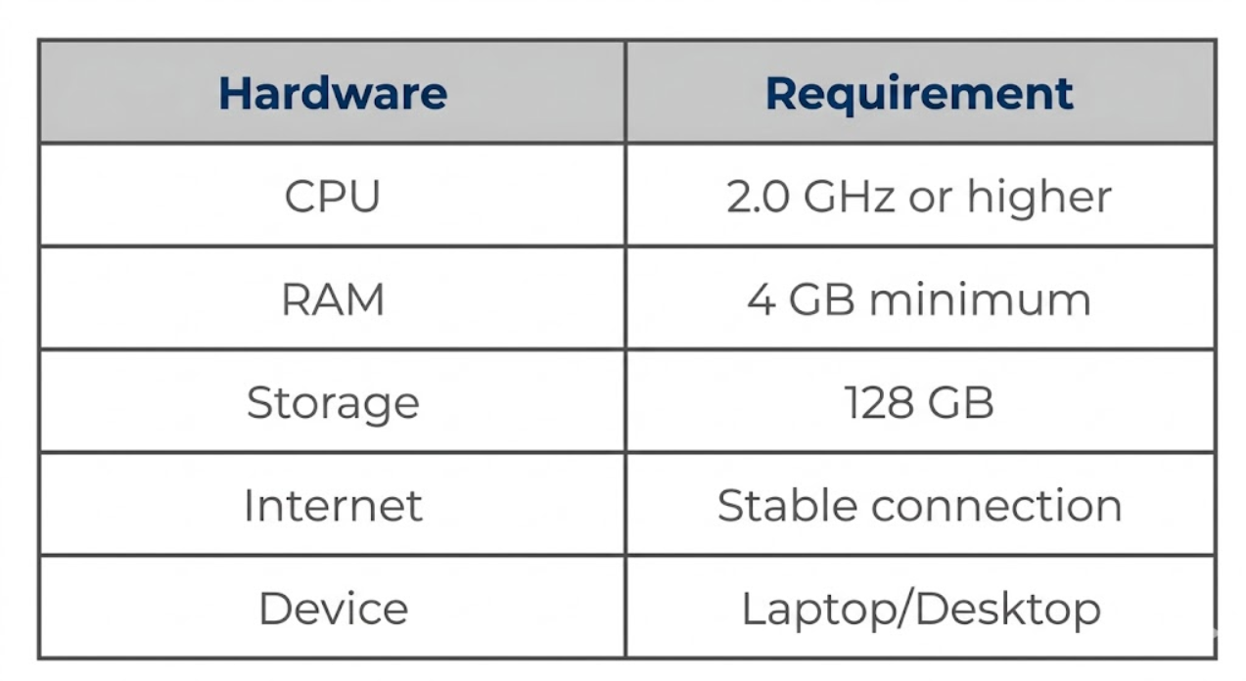

4.6 Software Requirements
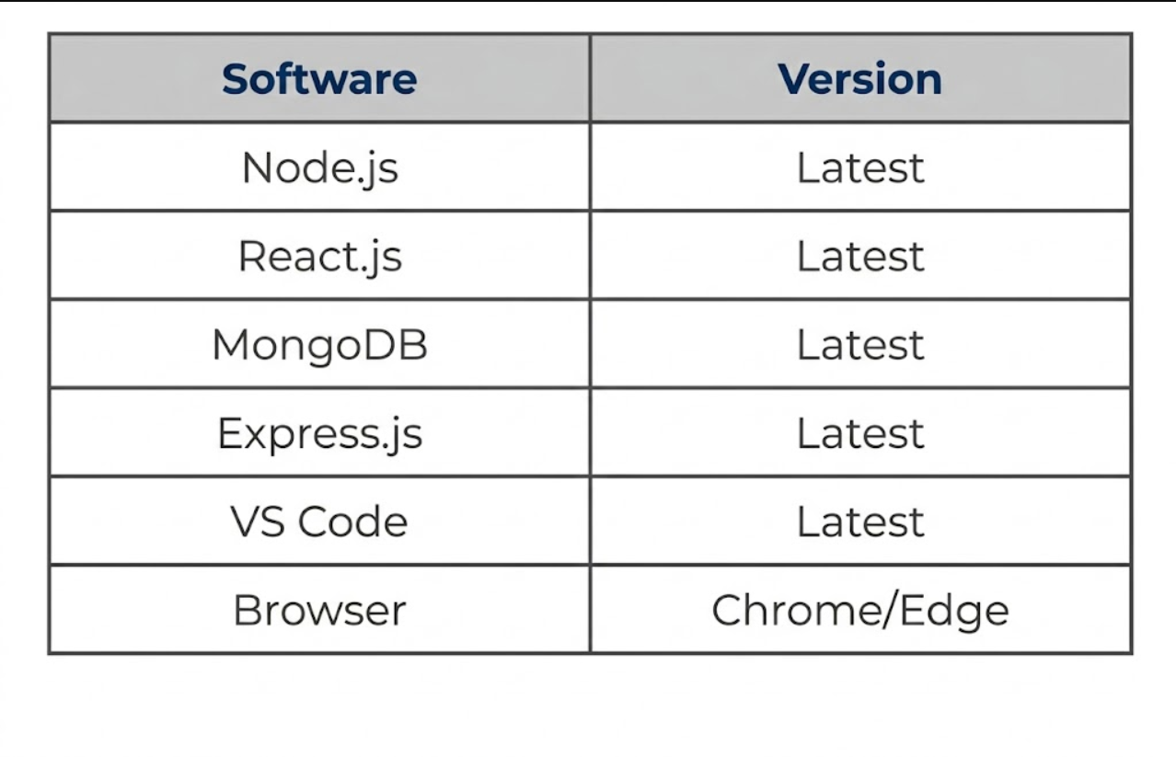

CHAPTER 5
SOFTWARE REQUIREMENT SPECIFICATION (SRS)

5.1 INTRODUCTION
Vintage Parts India is a modern web-based marketplace platform developed to simplify the process of buying and selling vintage automobile parts. Traditional methods of sourcing rare vehicle components are inefficient, time-consuming, and unreliable because users depend on scattered offline markets, local contacts, and unverified sellers. This often results in counterfeit products, inconsistent pricing, and limited availability of genuine parts.
The proposed system replaces these traditional methods with a centralized digital platform where users can search, browse, upload, and purchase vintage automobile components efficiently. The system provides features such as user authentication, product listing management, advanced search and filtering, seller dashboards, image uploads, and product management functionalities.
Through Vintage Parts India, buyers can discover rare automobile parts using detailed search filters such as category, price range, vehicle type, and availability. Sellers can upload products with images, descriptions, and pricing details, enabling better visibility and accessibility.
The system is designed using modern technologies including React.js for frontend development, Node.js and Express.js for backend APIs, and MongoDB for database management. The platform improves transparency, accessibility, and reliability while reducing search effort and transaction complexity.

5.2 PURPOSE AND SCOPE OF SRS
The purpose of this Software Requirement Specification (SRS) document is to define the complete functional and non-functional requirements of the Vintage Parts India system. It describes the system architecture, user interactions, data handling, constraints, and expected behavior of the platform.
This document serves as a guideline for developers, testers, project evaluators, and future maintainers of the application. It ensures that all stakeholders understand the objectives and functionalities of the system clearly.
The scope of the project includes:
- User registration and authentication
- Product listing and management
- Search and filtering system
- Product image uploads
- Buyer and seller dashboards
- Order and inquiry handling
- Admin monitoring and management
The system is designed for vintage automobile enthusiasts, collectors, restoration workshops, and automobile part sellers. It can be expanded in the future with payment gateway integration, mobile applications, blockchain-based verification, and AI-powered recommendations.

5.3 USAGE SCENARIO

The usage flow of Vintage Parts India is designed to provide a smooth and efficient user experience.

Buyer Flow
- User opens the platform in browser.
- User registers or logs into the system.
- User browses available products.
- User applies filters based on category or price.
- User views detailed product information.
- User contacts seller or places inquiry.
- User saves products for future reference.

Seller Flow
- Seller logs into the platform.
- Seller opens dashboard.
- Seller uploads product details and images.
- Seller manages listed products.
- Seller updates pricing and availability.

Admin Flow
- Admin monitors platform activity.
- Admin manages users and products.
- Admin removes invalid or fraudulent listings.
- Admin handles reports and moderation.

5.4 USER PROFILE
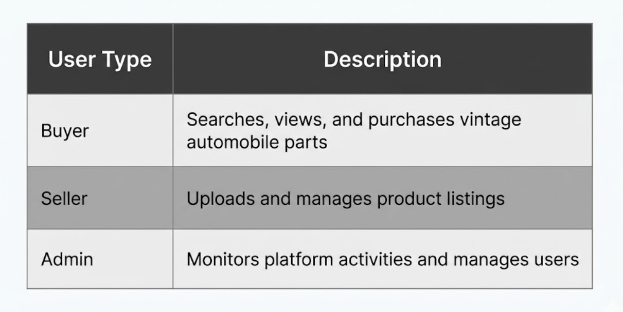

CHAPTER 6 DETAILED DESIGN DOCUMENT

6.1 SYSTEM ARCHITECTURE
Vintage Parts India follows a three-tier client-server architecture consisting of Presentation Layer, Application Layer, and Data Layer. This architecture helps in improving scalability, maintainability, security, and communication between different components of the system.
The frontend layer handles user interaction and interface rendering. The backend layer processes business logic, authentication, APIs, and product operations. The database layer stores all application data such as users, products, categories, and inquiries.
The architecture ensures smooth communication between users and the system while maintaining modularity and performance.

6.1.1 SYSTEM ARCHITECTURE DIAGRAM
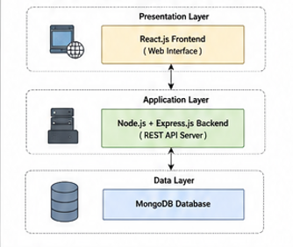

1. Presentation Layer (Frontend)
The frontend is developed using React.js. It provides a responsive and user-friendly interface for buyers, sellers, and administrators.
Main Pages:
- Home Page
- Login/Register Page
- Product Listing Page
- Product Details Page
- Seller Dashboard
- Admin Dashboard
- Upload Product Page
The frontend handles:
- User interaction
- Product browsing
- Search filtering
- Form submissions
- Product uploads

2. Application Layer (Backend)
The backend is developed using Node.js and Express.js. It manages all core business logic and communication between frontend and database.
Main Modules:
- Authentication Module
- Product Management Module
- Search Module
- Inquiry Management Module
- Admin Management Module
- Image Upload Module
REST APIs are used for communication between frontend and backend.

3. Data Layer (Database)
MongoDB is used as the database for storing application data securely.
Collections:
- Users
- Products
- Categories
- Orders
- Inquiries
- Admins

6.2 CLASS DIAGRAM
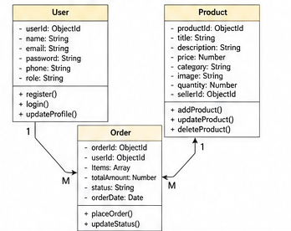

The class diagram represents the static structure of the Vintage Parts India system by showing major entities, their attributes, functions, and relationships.
The major classes included in the system are:
- User
- Product
- Order
The User class represents buyers who browse products and contact sellers. The Seller class manages product uploads and inventory operations. The Product class stores product-related information such as title, category, price, and description.
The Category class organizes products into groups. The Inquiry class handles communication between buyers and sellers. The Admin class manages moderation and monitoring activities.
The relationships between these classes define the working of the system. Sellers upload products, users browse products, inquiries are sent to sellers, and admins monitor platform activity.

CHAPTER 7 PROJECT IMPLEMENTATION
7.1 IMPLEMENTED MODULES
Vintage Parts India is developed using a modular architecture where each component performs a specific task to ensure smooth and efficient marketplace operations.
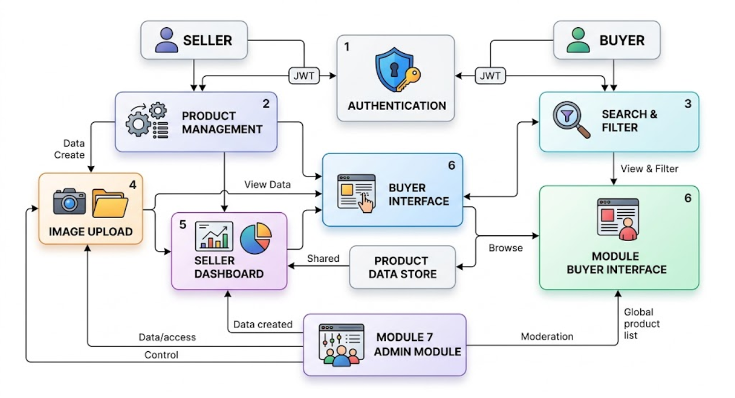
1. Authentication Module
Provides secure user registration and login functionality using JWT authentication.
2. Product Management Module
Allows sellers to upload, edit, delete, and manage vintage automobile parts.
3. Search and Filter Module
Provides advanced filtering based on category, price, and keywords.
4. Image Upload Module
Allows sellers to upload product images for better product visualization.
5. Seller Dashboard
Enables sellers to manage inventory and listings efficiently.
6. Buyer Interface
Allows users to browse and interact with products.
7. Admin Module
Provides moderation and platform management functionalities.
7.2 BACKEND APIs
The backend is developed using RESTful APIs for communication between frontend and server.
Main APIs
Authentication APIs
- /api/auth/register
- /api/auth/login
Product APIs
- /api/products
- /api/products/:id
User APIs
- /api/users
Inquiry APIs
- /api/inquiries
Admin APIs
- /api/admin
These APIs handle:
- Authentication
- Product operations
- Inquiry handling
- Data retrieval
- Admin moderation

CHAPTER 8 SOFTWARE TESTING

8.1 TYPES OF TESTS PERFORMED

Vintage Parts India was tested using different methods to ensure reliability and proper functionality.
Unit Testing
Individual modules and functions were tested separately.
Functional Testing
Features such as login, product upload, and product search were verified.
Validation Testing
User input validations were tested.
UI Testing
User interface responsiveness and display behaviour were tested.
Security Testing
Authentication and protected routes were tested.

8.2 TEST RESULTS
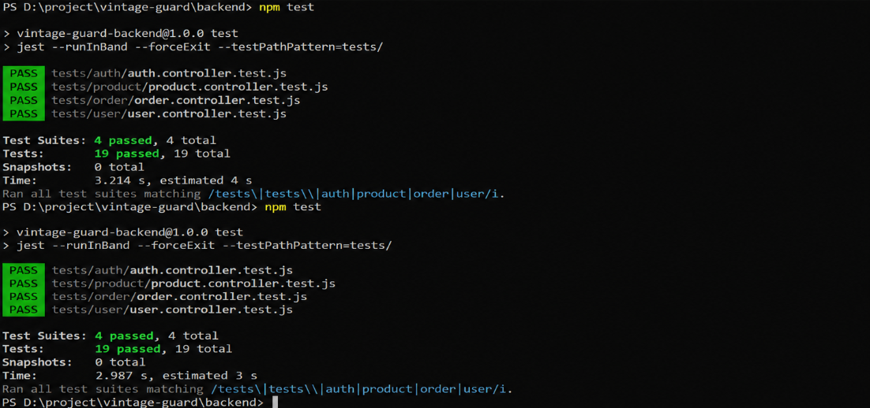

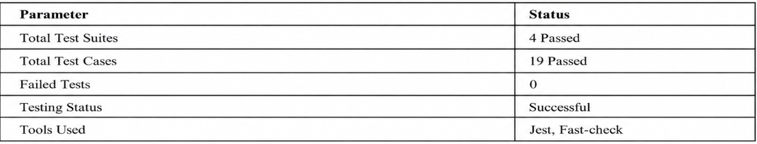

CHAPTER 9 ADVANTAGES OF SYSTEM

Vintage Parts India offers many advantages over traditional offline marketplaces.

Advantages:
• Centralized marketplace
• Easy product discovery
• Improved accessibility
• Better transparency
• Reduced search time
• User-friendly interface
• Seller inventory management
• Secure authentication
• Faster communication
• Scalable platform
• Better customer experience
• Supports rare automobile restoration community

CHAPTER 10 LIMITATIONS OF SYSTEM

Although Vintage Parts India provides an efficient digital marketplace solution, certain limitations exist.
Limitations:
- Requires internet connection
- Dependence on server availability
- Initial low product database
- No integrated payment gateway currently
- Image storage limitations
- High traffic may affect performance
These limitations can be improved in future versions of the system.

CHAPTER 11 FUTURE ENHANCEMENT

Vintage Parts India can be improved further using advanced technologies and additional features.
Future Enhancements:
- Mobile application
- Online payment gateway
- AI-based product recommendations
- Blockchain verification for authenticity
- Chat system between buyers and sellers
- Multi-language support
- Cloud deployment
- Analytics dashboard
- Real-time notifications
- Wishlist system

CHAPTER 12 CONCLUSION

Vintage Parts India successfully transforms the traditional process of sourcing vintage automobile parts into a modern digital marketplace platform. The system eliminates dependency on scattered offline markets and provides a centralized environment where buyers and sellers can interact efficiently.
The platform improves accessibility, reduces search effort, and increases transparency by allowing users to browse detailed product listings and communicate with sellers directly. Features such as authentication, search filtering, seller dashboards, and product management improve the overall user experience.
The system demonstrates how modern web technologies such as React.js, Node.js, Express.js, and MongoDB can be used to solve real-world marketplace problems effectively. Overall, Vintage Parts India provides a scalable, reliable, and user-friendly solution for the vintage automobile community.

CHAPTER 13 REFERENCES

• React.js Official Documentation

• Node.js Official Documentation

• Express.js Documentation

• MongoDB Documentation

• Mongoose Documentation

• REST API Concepts

• JWT Authentication Documentation

• JavaScript Official Documentation

• GitHub Documentation

GLOSSARY

The following glossary explains the important technical terms and technologies used in the development of the Vintage Guard project. UI (User Interface) refers to the visual interface through which users interact with the application, while UX (User Experience) defines the overall usability and ease of navigating the platform. API (Application Programming Interface) is used for communication between the frontend and backend of the application. REST API is a web service architecture that uses HTTP methods such as GET, POST, PUT, and DELETE for data exchange and operations.
React.js is the frontend JavaScript library used to create responsive and interactive user interfaces. Node.js is the JavaScript runtime environment used for backend server development, while Express.js is the web framework used for building APIs and handling server-side routing. MongoDB is the NoSQL database used for storing user data, product information, and application records. JWT (JSON Web Token) is used for secure user authentication and authorization within the system.
CRUD operations represent Create, Read, Update, and Delete functionalities used for managing data inside the database. Authentication is the process of verifying user identity during login, while authorization controls access permissions for different users. The frontend represents the client-side part of the application visible to users, whereas the backend handles server-side processing and business logic.
JSON (JavaScript Object Notation) is the lightweight data format used for communication between frontend and backend systems. Middleware is a software layer that processes requests before reaching the main application logic. Deployment refers to the process of hosting the application online on a server or cloud platform. GitHub is the version control platform used for source code management and collaboration during development. Security refers to protecting application data and preventing unauthorized access, while scalability defines the system’s ability to handle increasing users and data efficiently. Performance refers to the speed, responsiveness, and efficiency of the overall application during usage.

